Report for homework 1 - computer vision

By Lavanya.shirur – 1616056

Problem definition - Segmentation of grayscale and color image using K Means algorithm

K-Means is a least-squares partitioning method that divide a collection of objects into K groups. The algorithm iterates over the following steps:

1. Assign centroids randomly using the random number generation
2. Compute the distance of each point from each centroid by computing its distance
3. Assign each point to the cluster it is nearest to
4. Compute the mean of each cluster
5. Change the centroid value to the new mean of the cluster
6. Iterate over the above steps till the centroids value does not change

a. What are the parameters that influence your algorithm? Explain their effect?

The parameters that influence algorithm are –

The number of clusters chosen – if there are more number of clusters the data points have to be divided into different clusters and more clear the image looks. In case of color images there will be more shades of colors of the images which makes segmentation more accurate.

The number of iterations selected – in my code I have selected 5 iterations which is not the best number. More number of iterations will provide more clear segmented image

The image size – more the size of the image more is the time taken to segment the image, for example fruit.jpg is the biggest file and it takes more time to get segmented because of the large number of pixels

Whether the image is gray scale or color – this also influence the algorithm, because if its gray scale there will be one variable to be considered that is intensity value of the pixel , but if the image is color then there are 3 values to be considered , the intensity of red , green and blue pixels , image is 3D in case of color images

b. Does your segmentation code always generate the same segments for a given k. Explain?

no ,the segmentation code does not always generate same segments for a given k . because we are choosing the initial centroid randomly , the initial value of centroid is not fixed ,

In the image the number of pixels are fixed and the number of ‘k’ or clusters is also fixed , but the initial centroids are different and its chosen randomly using random.randint(x,y)

Suppose in case 1 The centroids are 1 and 220 then the data points near to 1-100 will be moved into cluster1 and data points near 100-256 will be moved to cluster 2 , then the mean of cluster 1 will be found and then the centroid1 will be between 1-100 , and all data points concentrate near mean of 1-100. This will be centroid 1. Similarly for centroid2.

But if in case 2 , the initial centroids are 200 and 250 then the data points from 1-200 will be concentrated near 200 and the mean of cluster 1 will be between 1-200 . and the second centroid will be concentrated near 250. So even though the k is same the segmentation code always generate different segments. As we can see from figure 1 and 2 below.

Fig 1 –circles with k = 3

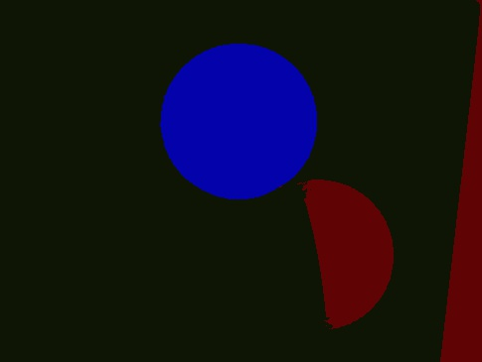

Figure 2 – circles with k =3.

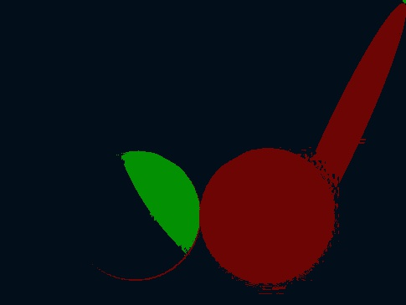

c. What is the objective of this implementations? Which set of features perform better (color vs greyscale)? Explain?

The objective of this implementation is learning the K means algorithm implementation and how to segment the images if they are grey scale or if they are color images. We can learn the following points from the implementation

* The pixel value representation of Grey scale images and Color images
* The complexity of handling color images
* The parameters that influence the k means algorithm implementation like the influence of having more number of clusters , more number of iteration , sizes of the images
* The color images perform better compared to grey scale images
* As there are 3 dimensions for a color image and there is more depth for color images we can see segmentation of variation of different color shades across R G B color values.
* Segmentation is more clear in color images . as we can observe more segments as the number of clusters increases there will be more clusters and clearer the image is.

The sample output images are as follows



